SURESH

Power BI Session

Module 6

**Direct Query**

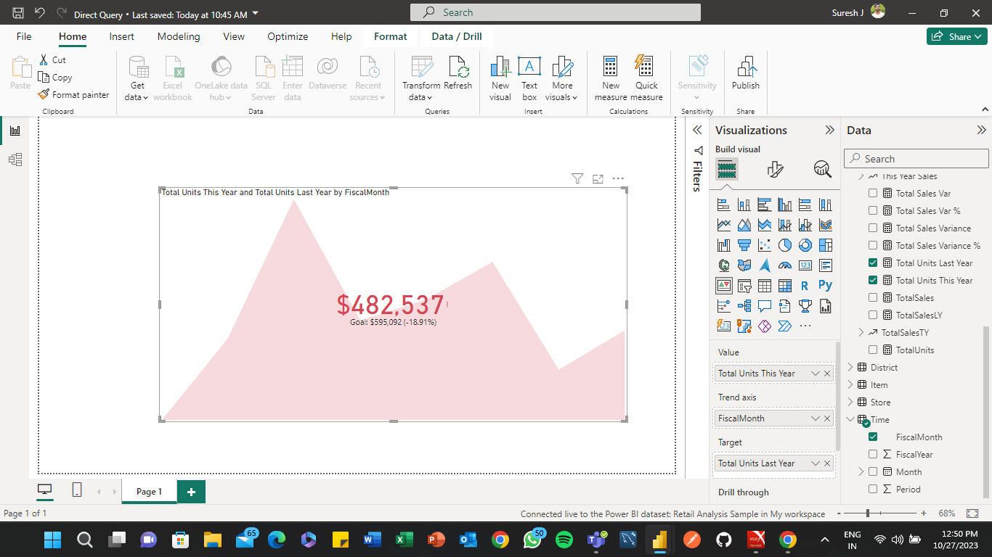

**Total Using Calculate and Sumx Function**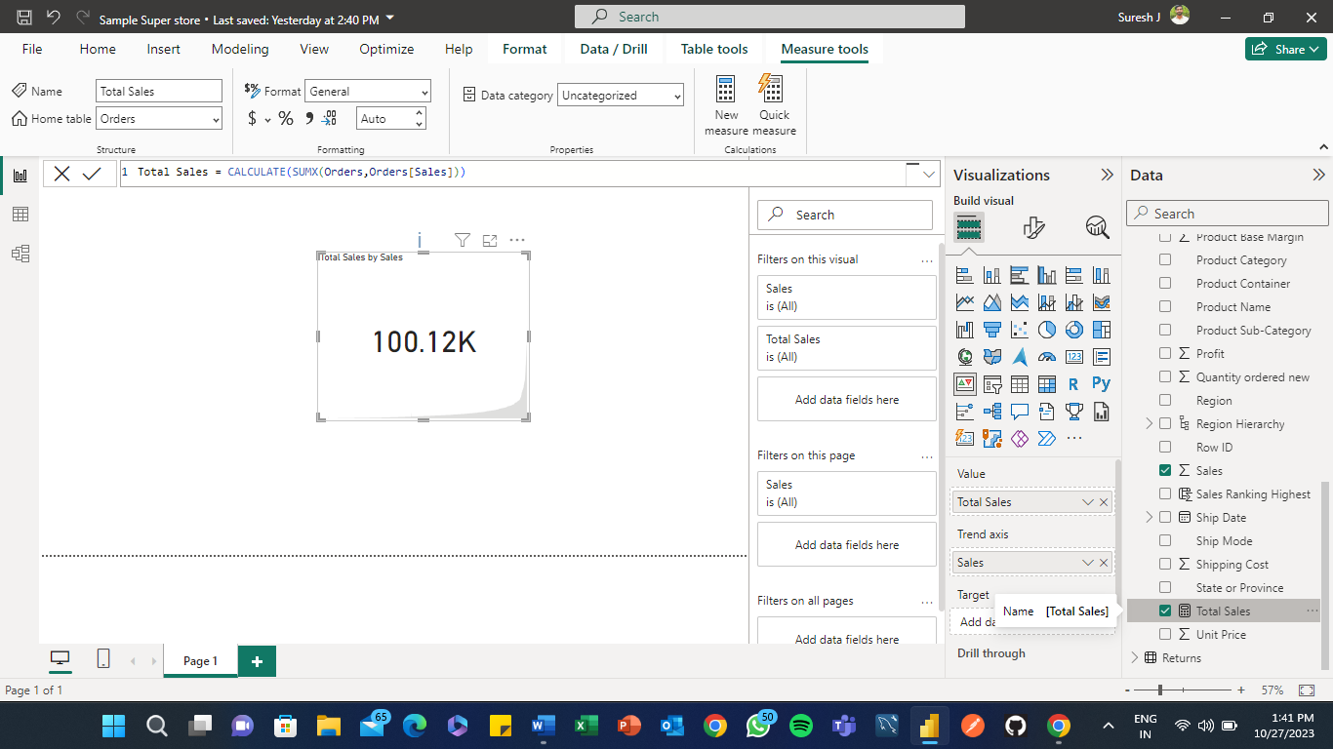

**Creating a Measure for fetch the Specific year sales using Variable, Return and Calculate Functions**

**2010 Corporate Sales**

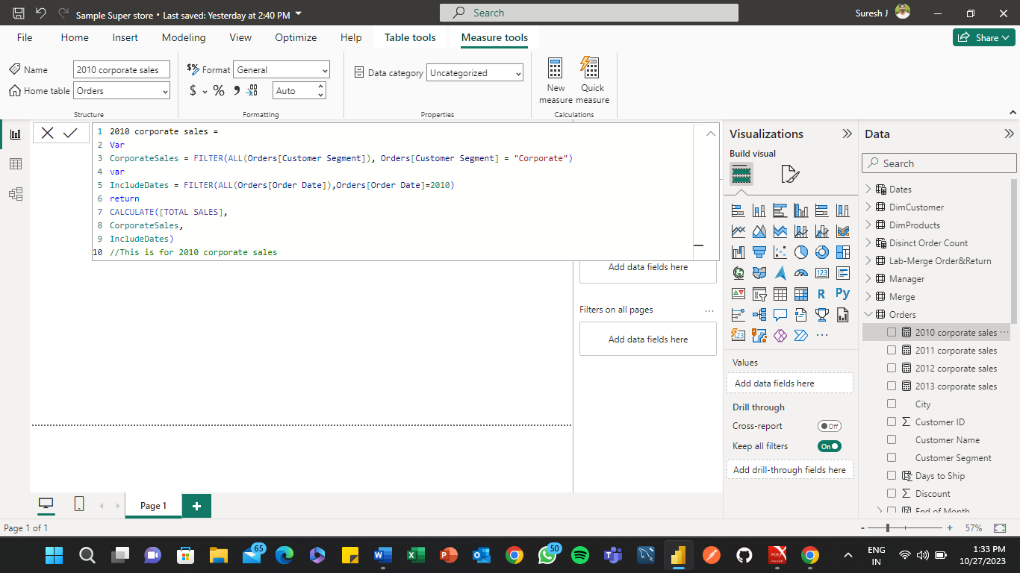

**2011 Corporate Sales**

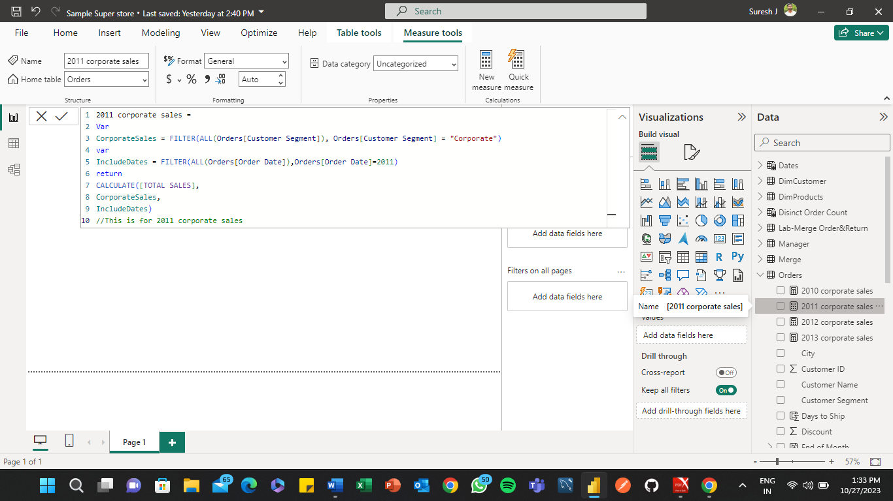

**2012 Corporate Sales**

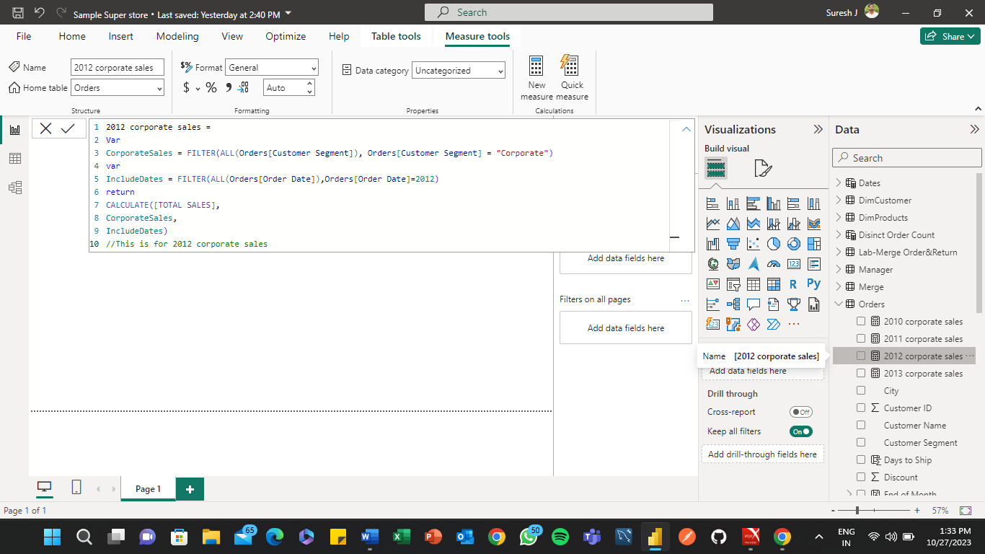

**2013 Corporate Sales**

